Dibawah ini katalog product nya wear label ya

All celana size only M, L dan XL, kecuali untuk yg cerra loose big pants

Untuk cardigan gini

Miu cardigan
INT | Panjang Atasan  (cm) | Lingkar Dada  (cm) | Panjang Lengan Baju  (cm)
All Size | 58 | 100 | 55

Nori cardigan
INT | Panjang Atasan  (cm) | Lingkar Dada  (cm) | Panjang Lengan Baju  (cm)
All Size Fit to L | 57 | 94-100 | 54

Darla Vest
INT | Panjang Atasan  (cm) | Lingkar Dada  (cm)
All Size | 62 | 110
Rui cardigan
INT | Panjang Atasan  (cm) | Lingkar Dada  (cm) | Panjang Lengan Baju  (cm)
All Size | 59 | 104 | 53

Basic Linen Culotte

Black
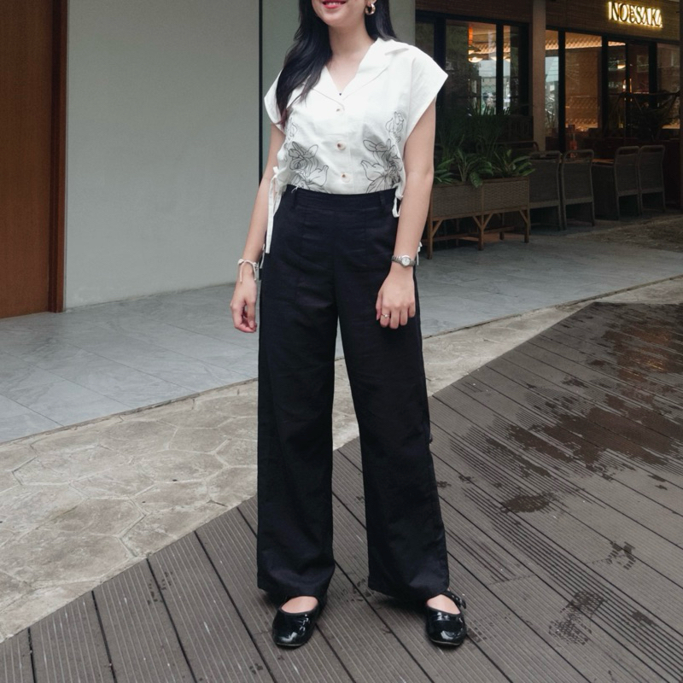
Broken white+furing
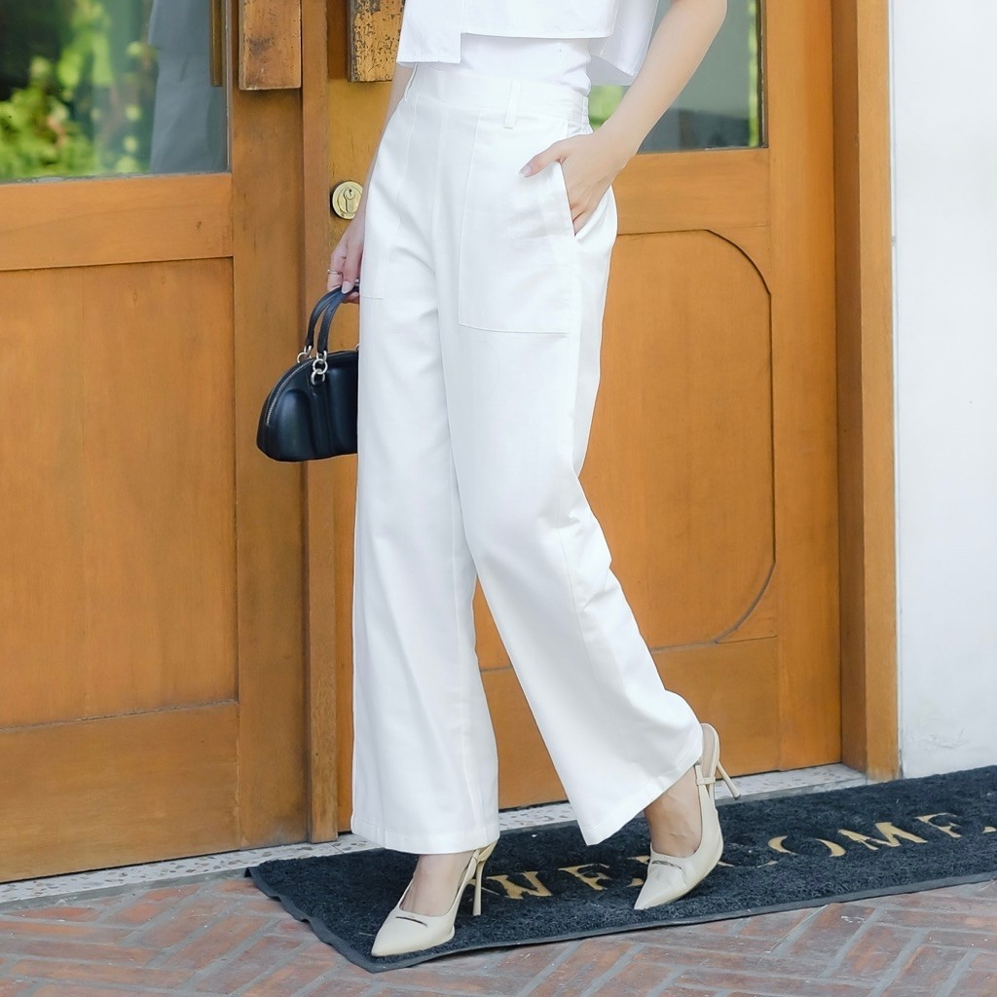
Cream
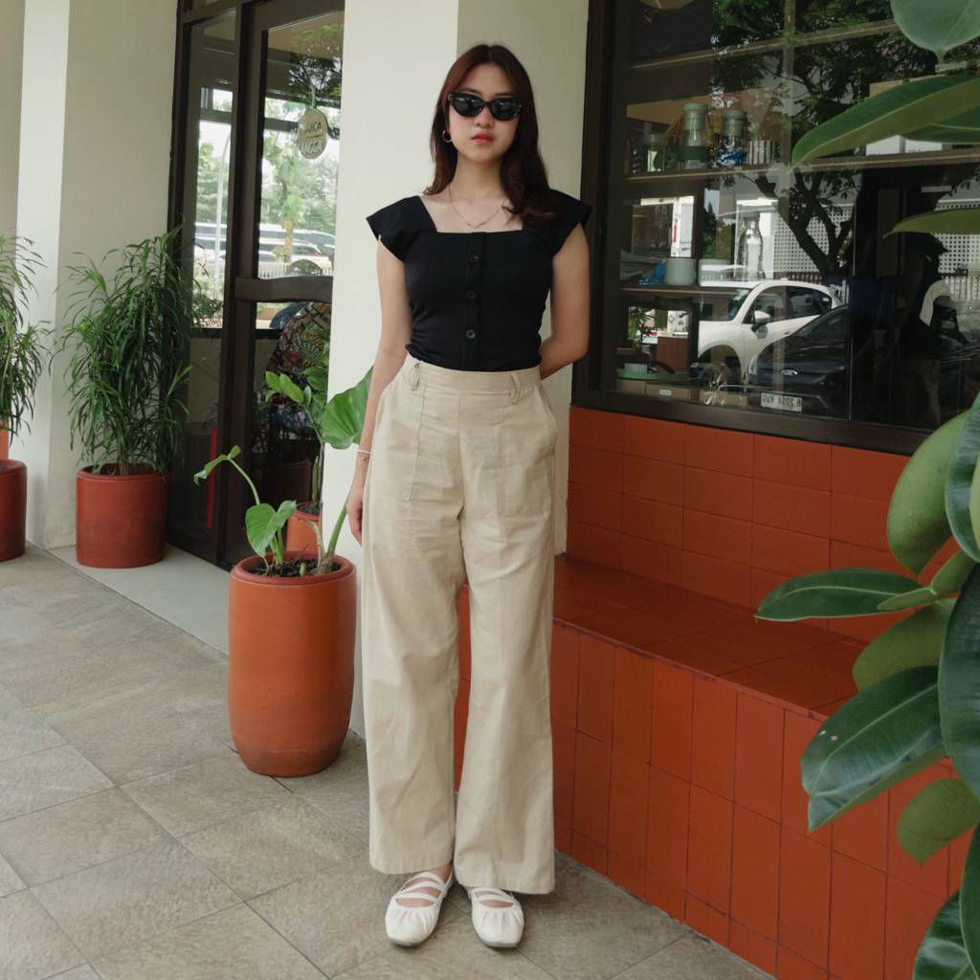
Pipo Pants
Black
grey
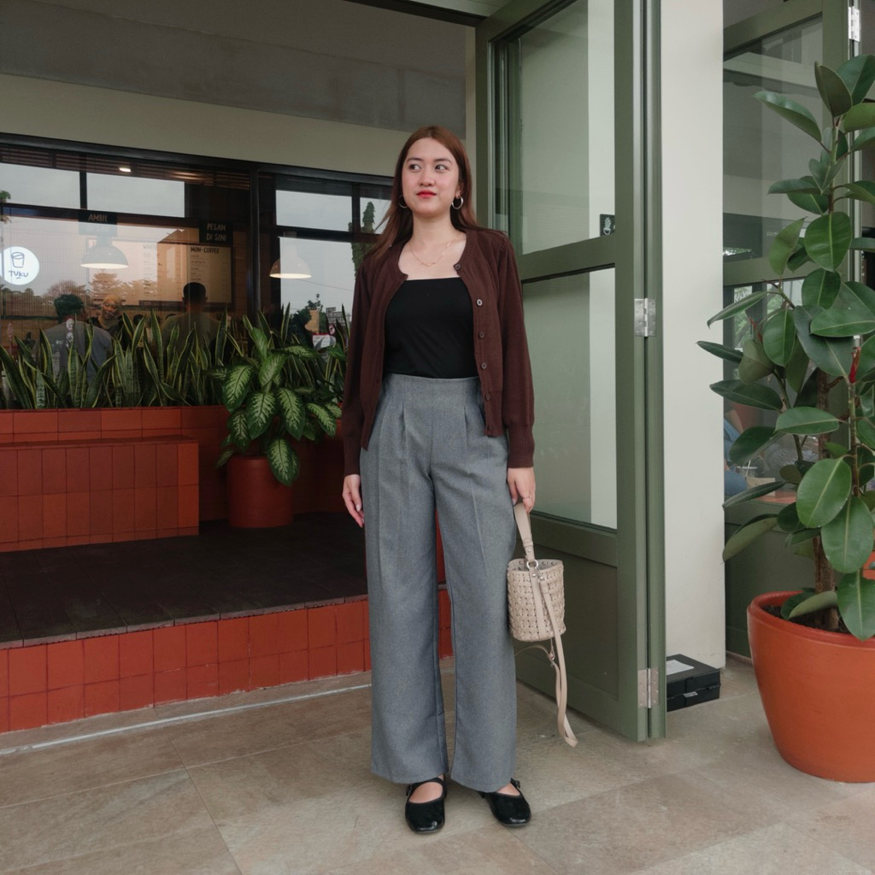ivory
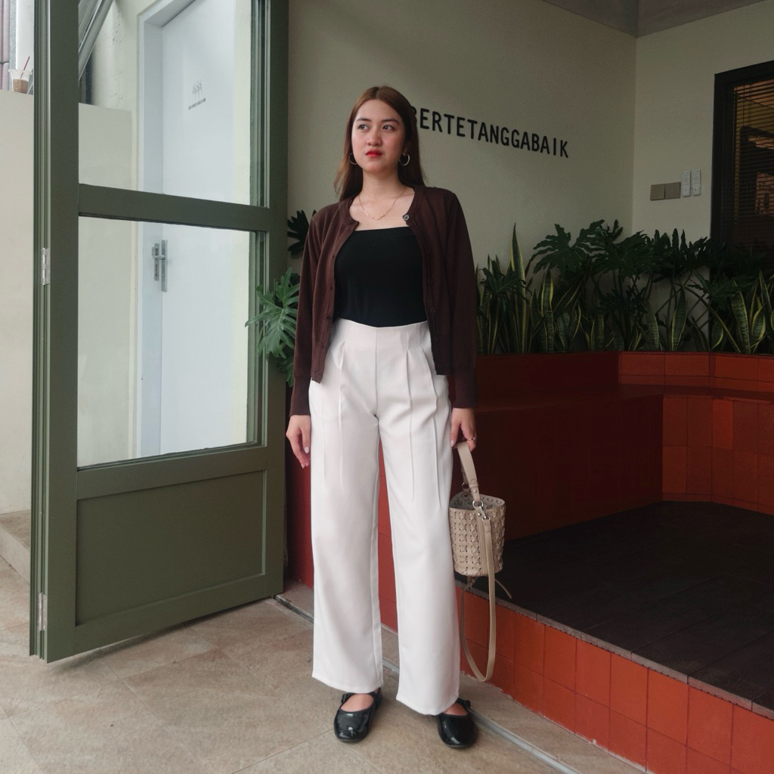
Choco
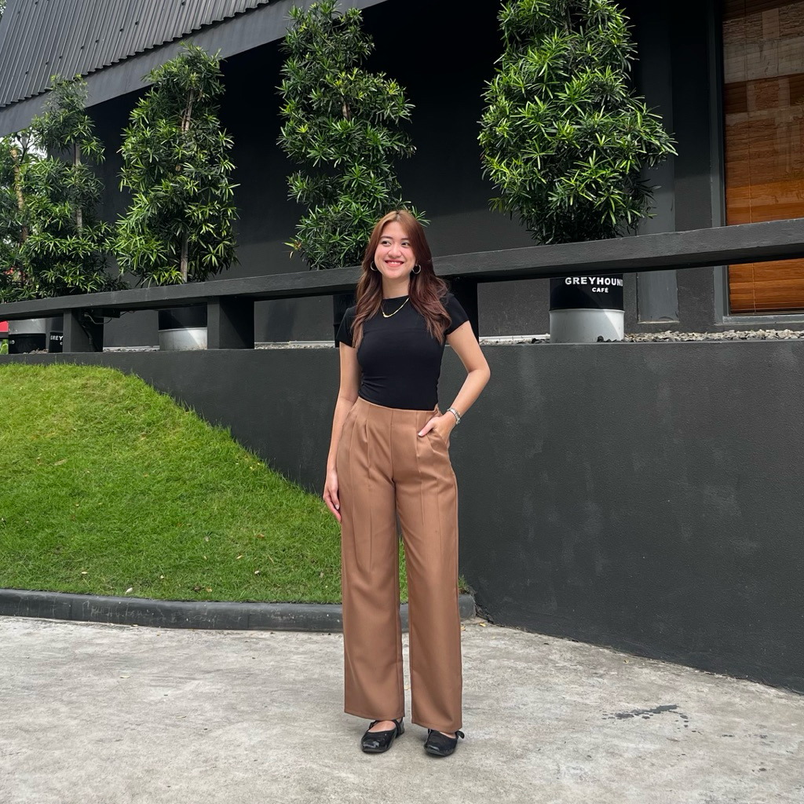
Casual Culotte Linen
Broken white + furing
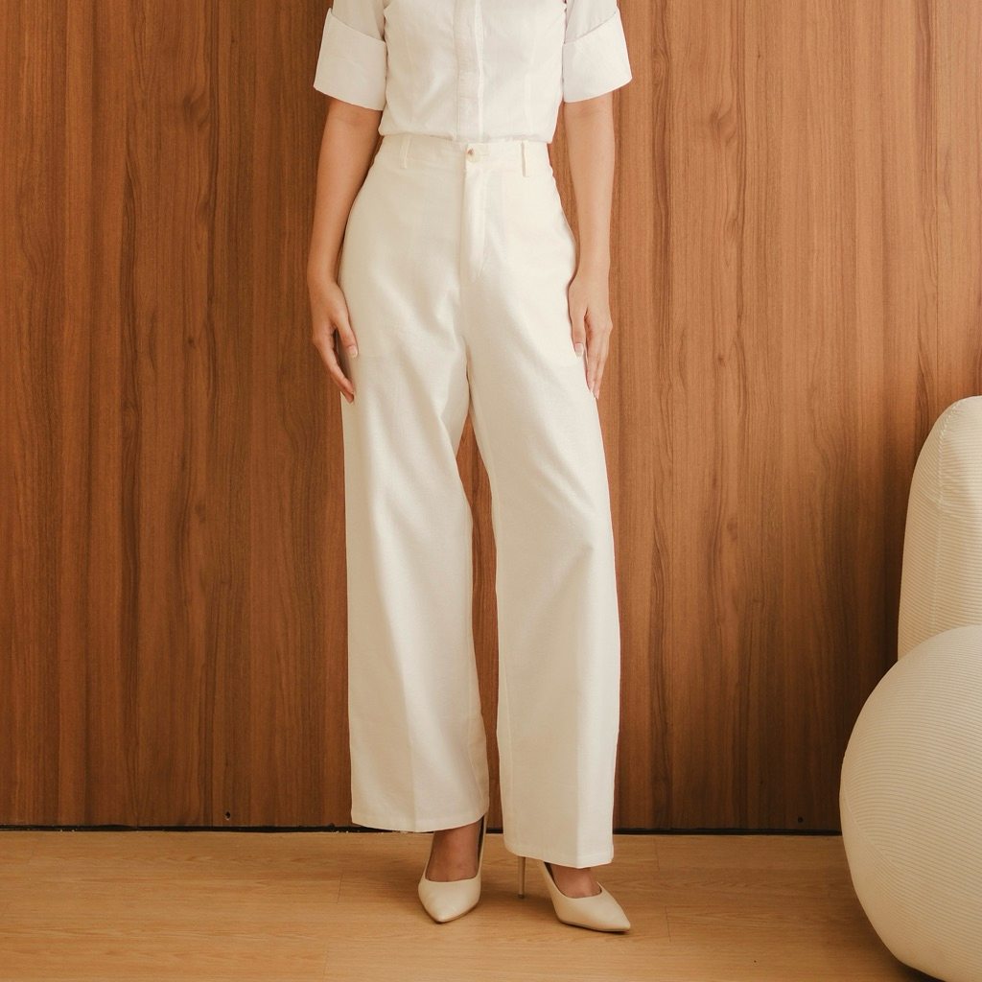
Cream
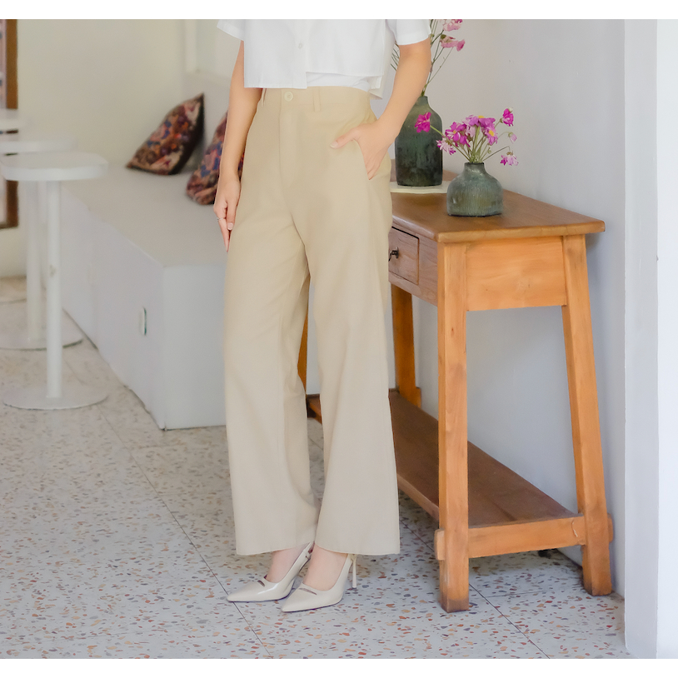
Choco new
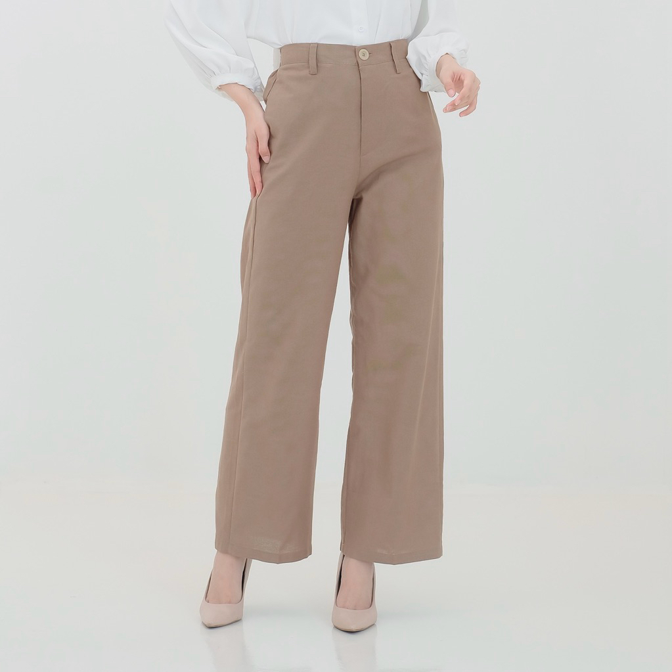
Black
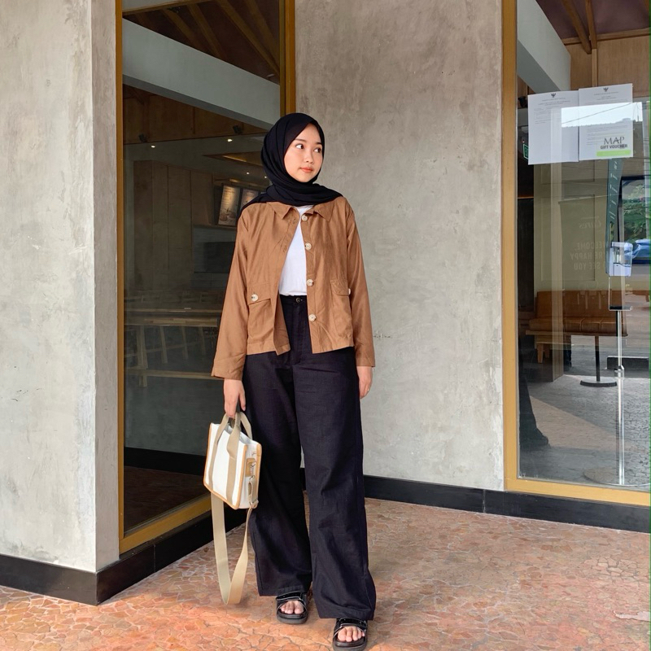
Army
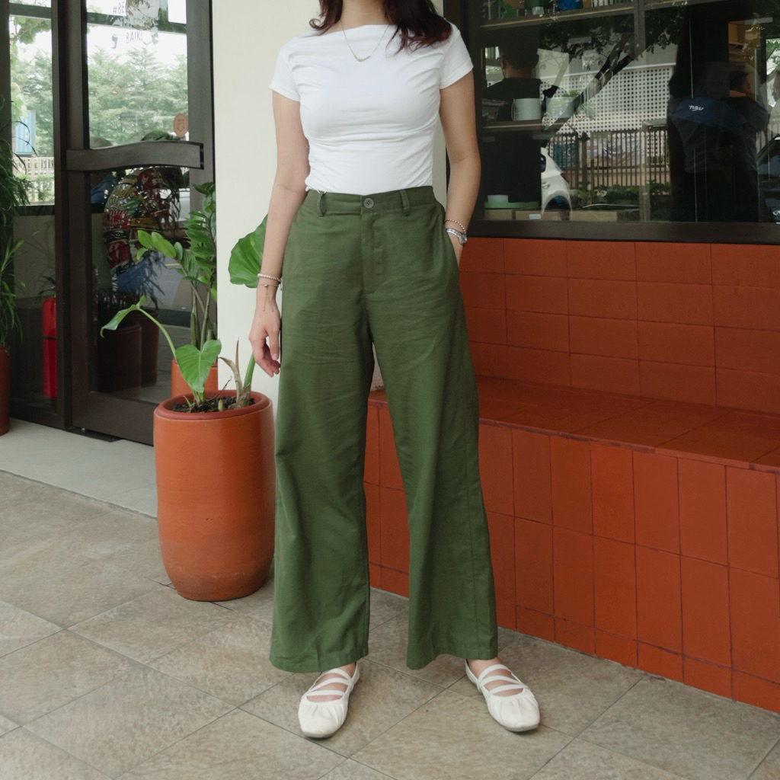
Black lilo
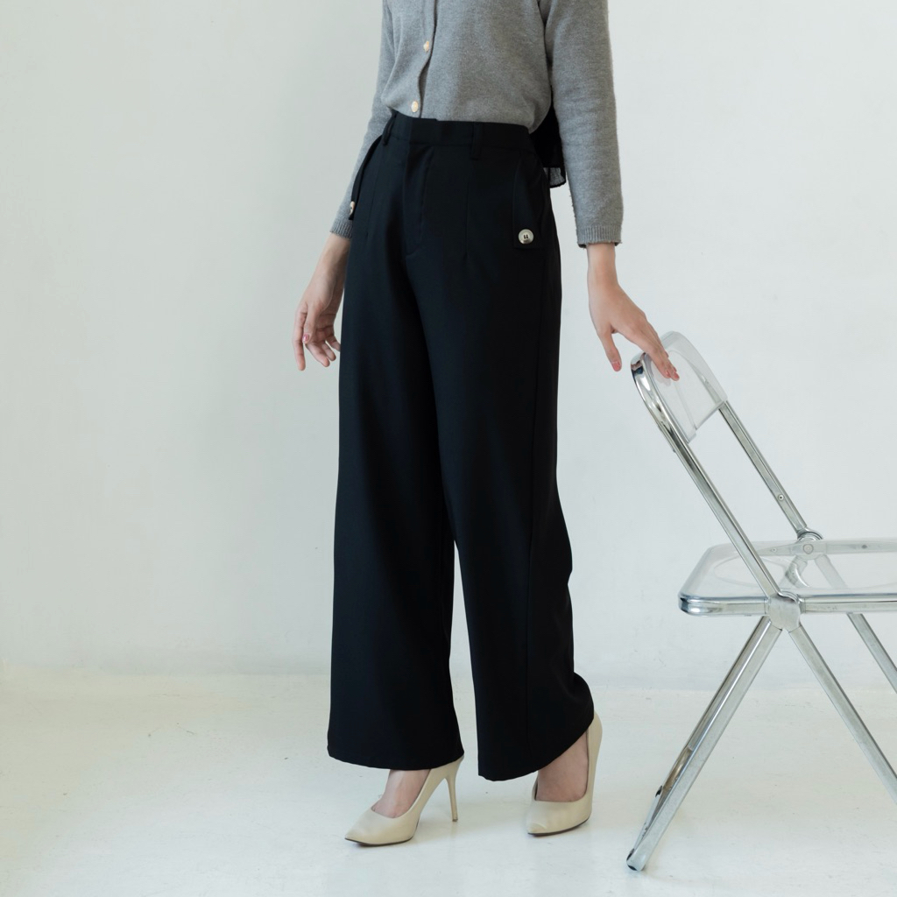
Ivory lilo
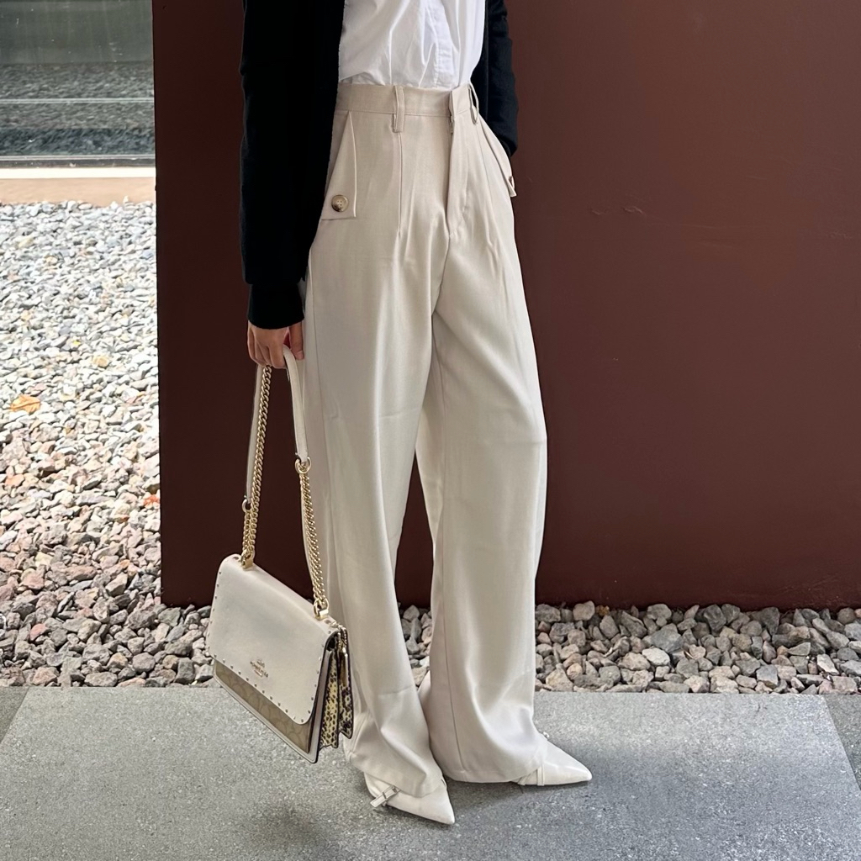
Grey lilo
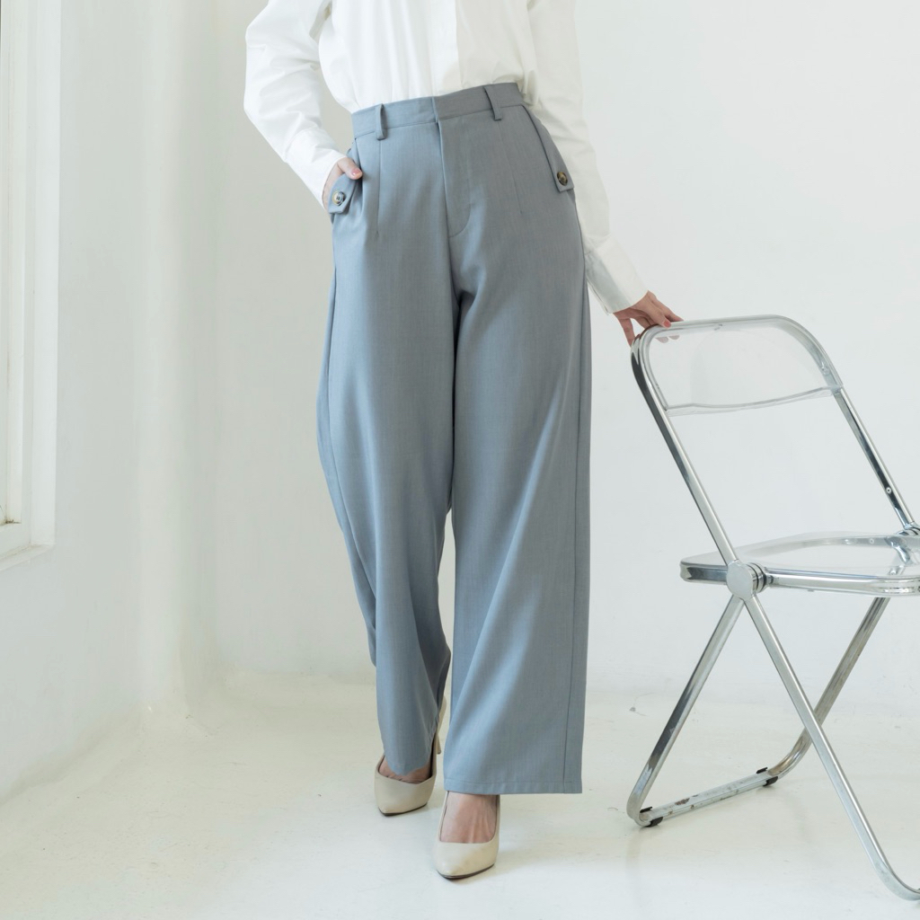
Blue lilo
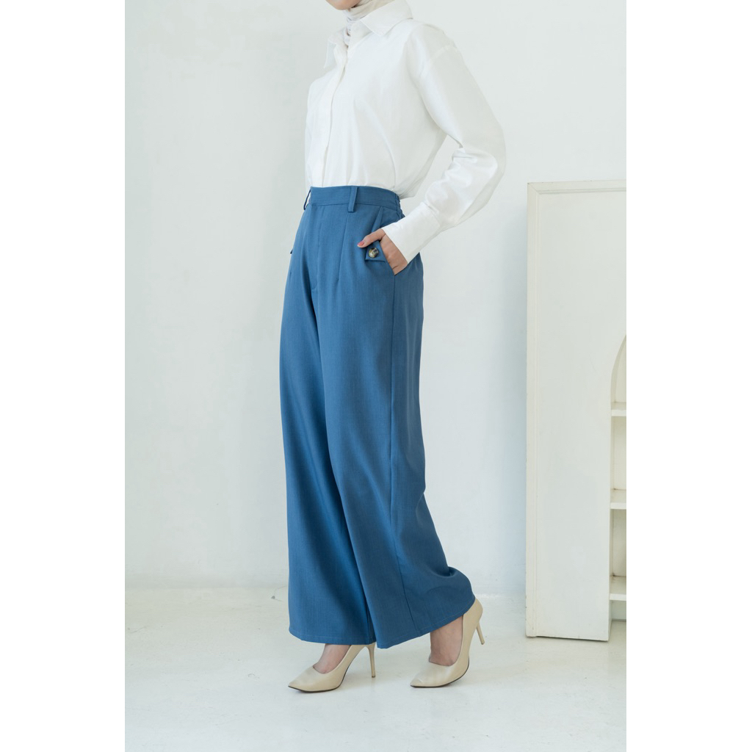
Cerra Loose Pants
Warna
blackmilo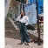emerald greengreen limebroken white+furing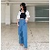royal blue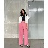pink candy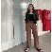dark chocolatenavycream blossomKhakismoky greylavender

Cerra loose pants big size
Warna
blackcoksumilo

navy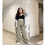sage green (new)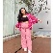pink candy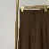dark chocolate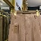cream blossom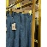royal bluetaroemerald greenlight grey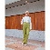green limeKhaki

Khusus ini size nya only XXL

Dalia wide pants
Warna
BlackGreyOliveDark Choco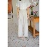IvoryBlue

Milly Stripe pants
Warna
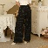Black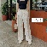Ivory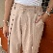Cream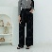Black (Tara)

Miu cardigan
Warna
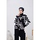Black-White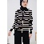Black-Cream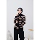Black-Choco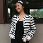White-Black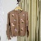Milo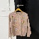Mocca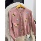Nude PinkBroken WhiteIvory Pearl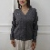Grey PearlBlack PearlChoco Pearl
Moa pants
Warna
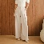IvoryCreamBlack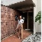ChocoGrey
Pallo pants
Warna
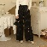BlackIvoryCream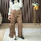Choco
Soso pants
Warna
CreamBlackOlive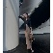Choco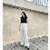Broken white+furing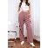HazelnutMidnightemerald green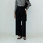Black (soso)Ivory (Soso)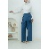Blue (Soso)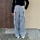Grey (Soso)

Warna
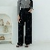Black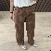Choco
Yora Loose Pants
Warna
blackchoco (semiwool)navyivory (semiwool)broken white+furinggrey (semiwool)espressoblack (semiwool)tortillasand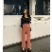rose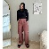brownie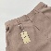coksugrey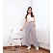light greyhoneycaramel (new)OliveGrey (LW semiwool)Ivory (LW semiwool)Choco (LW semiwool)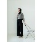Black (LW semiwool)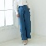Blue (LW semiwool)
Nori Cardigan
Warna
BlackGreyChoco
Rui cardigan
Warna
Coksu - MaroonCream - PinkCream - MaroonNavy-MaroonNavyGreyCreamChoco
Darla vest
Warna
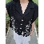BlackCreamWhiteKhakiSage Green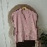Pink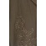Choco

